PRESS RELEASE- For immediate release
Milano, 28th March 2017
Discovering Din – Design In 2017
DIN-DESIGN IN 2017
#din2017
The unmissable event of the design world is coming and for the Milan Design Week 2017 Promotedesign.it will again organize the big exhibitory event Din-Design In, in the strategic location of via Massimiano 6/ via Sbodio 9 – Ventura Design District, in Lambrate.
As for the previous editions there will be the chance to admire the ideas of more than 100 designers from all over the world with more than 600 products exhibited, from hi-tech items to creations with a high artistic and innovative features. The Milan Design Week will start on Tuesday 4th April 2017 and it will finish on Sunday the 9th April 2017. Din-Design In will become once again the temple of the international self-produced design. Thanks the organization of the several and different initiatives, such as the extraordinary opening until midnight of April 5th and the event wEating 2017and the Temporary Shop of Artistar Jewels, the event will be one of the most important and popular ones during the Milan Design Week 2017.
The give a further boost to the event there will also be the internationally famous architects Simone Micheli, who, during the Milan Design Week will give birth to “Heart’s serviced apartments for Art – Business – Mountain - Sea” a new concept related to the world of hospitality and addressed to promotion and the presentation of the innovation of design.
Promotedesign.it has as primary goal putting in contact and attracting the interest of the design-producers and buyers and making them aware of the increasing creativity offer.
For this purpose, every year, various collateral events are created, like the Temporary Shop area in which Artistarjewels.com is reconfirmed after last year’s success. Artistarjewels.com is an e-commerce channels oriented to the online sale of design items and contemporary jewellery and Din – Design In if for it the opportunity of emerging from the virtual world and selling directly through the Temporary Shop available only during the Din event.
Promotedesign.it will make things bigger and at Din – Design In 2017 presents the zero edition of wEating 2017 where the food truck concept renovate. This first edition is the starting point of a renovated connection between food and design that aims to give food a significant space. wEating is developed as a real event like Fuorisalone.
This first edition is the starting point of a renovated connection between food and design that aims to give food a significant space. This i show wEating is developed, as a real event like Fuorisalone, loved and followed by a heterogeneous audience, lover of good food and always seeking for food-tasting places around the city.

For the set-up, cardboard is the protagonist of the setting up for the exhibitory event Din - Design In 2017, but its concept evolves further into more graceful shapes and into an offert primary addressed to the installation of commercial spaces or shops.
Please welcome a new perspective of cardboard that to our Main Sponsor because the furniture of Carton Factory offer a range of elegant design thought to give new life to empty spaces. And it’s not over yet! On the location also Be Different that will provide part of the outer installation created with the innovative polymass.
At the entrance, thanks to PRINTITALIA and it fantastic cardboard cactus realized for Din – Design In 2017.
From April 4th to April 9th the good design awaits for you in Lambrate, in via Sbodio, 6/ via Massimiano, 9.
The exhibitors
PRODUCT
15WEST STUDIO; 1unicodesign; Agnes Lukacs for Simplu makershop; Amitrani; Antonio Saporito; Arago Design; Balume; Bastian Design; Binario 4; Bloomboom; Carton Factory - Be Different; Davide Chiesa e Stefano Garoldi per DCD; Davide Montanaro - CDCables; Dipl Architektin Denise da Cruz Campitelli; drydesign; Elisa Campana; GIRO DEL MONDO di ALESSANDRO COMERLATI; HELLO PETS; Hexagón Design; Hexagro Urban Farming & Matthias Seitz / d-hoch-k; HOT DESIGN INNOVATION; In-es.artdesign; inutilDesign; INVENTOOM - design italiano; ION Project Lighting; IstroVeneto design; Joe Hanna Casey; Kasper Friis Egelund & Linnea Ek Blæhr; Kristoffer Munk / moijn; laBottega; Leave the sign; Lena Beigel; Leonardo Bueno Art&Design; LimeLAB; Lombroso Design; Maffam Freeform; Marco Barazzuoli; Marco Rubini Architetto; Mario Gorini; Martín Albarrán López & Eddie Figueroa Feliciano; Meonin; Metalli Filati; MOI ITALIA di Rossi Francesco; Muemma GmbH; NID Nuovo Istituto Design; noktuku; Notae Studio + Out of Necessity; OCCRA curating design; OfficinaWood; Officine Dasa srl; Oscar Acosta; Paolo Minola; PASSO 32; PlayWood di Space Matters srl & Plantui Italia; RI-NOVO; rmrp®; R-Studio\AladinoCarabelli; Ruggero Giuliani Architetto; Ruless-lab di Paolo Furno; Sapide / Atelier Design; Siderio; Simone Micheli Architect; Studio RDD; TKM-Teknometamorpho; Tojo Möbel GmbH; Troels Flensted; Uffici Creativi; Vetroricerca; Wai Ho Cheung; WALLI DESIGN; Yukiko Izumi.
JEWEL
Atelier Lewin; Blackout Label; Boltenstern; Cedric Chevalley; Dandy- Creations Of Paper; Ecaterina Gina Rotaru; EYE CANDY LAB; Ferdinando Colabraro; Fragolab; Gio di Già designer; Giovanna Andreis / Happening Lab; GiulianiDesign; Karibu; Kiki Designs & Body Ornaments; Lore Segers; Mara Paris; Morphè London; MyriamB by Myriam Bottazzi; Nature of the things; Paola Volpi; PIG’OH Ideemateriale; PLAITLY by Caroline Quinio; Proattivo; Raffaella Palmieri Gioielli; Saara Ruskola; Simona Girelli; Tiziana Redavid Ateliers; VERBA by Anna Fanigina.

SERVICE&FOOD
Logo Fausto Lupetti Editore; Printitalia; Apebedda; Aperia; Baladin; Brianza che nutre; Gelateria Cool; Il parmigiano; La Puccia; Las Bravas; Marchese - Cannoli on wheels.
DESIGN FOR CONTEST
Paolo Bandiello, Luisa Cappelli, LAMAA.
Projects developed by Promotedesign.it are:
Design For, a book/catalogue with the best design-concepts carefully chosen by Promotedesign.it; a very useful tool to all the manufacturing firms that have the possibility of selecting the best ideas from international designers.
Din-Design In, an expositive event created to give the chance to self-produced-designers to show their creations to an international audience and to allow a greater distribution of their concept-
Treneed.com, an e-commerce channel for the all the self-producer and the design enthusiast s that through the website have the possibility of selling and buying.
More info

Promotedesign.it
We are a collective of designers and architects whose goal is to promote creativity and design. Through the web portal and the offer of numerous service we put into contact all the actors in the sector. We collaborate with several bodies, as manufacturing firms, universities, specialized schools and publishing houses in order to favor the realization of different planning projects that help the increase of the debate.
The web portal also include several institutions related to the design universe, like prototype laboratories, photographers, press offices and more, to offer the registered users a network in constant change. The portal wants to be not only a useful working tool but also an opportunity to develop collaborations.
All the subscribers can create a professional profile from which manage independently all the personal information. In the profile the user will upload pictures of products, concepts, developing projects, descriptions of those projects and also a biography/cv. The system works for designers, firms and all those who wants a relevant service.
In addition, users will be offered the possibility of using promotional, learning and refreshing training services. Contests, free workshops, events, commercial partnerships are constantly offered.
More info
Information and Contacts for the Visitors
DIN – Design In
Dates: from 4th to 9th April 2017
Place: Via Massimiano 6 / via Sbodio 9 (Lambrate District)
Opening hours: everyday from 10 am to 8 pm
Extraordinary opening evening: ___ April from 10 am to 00:00
Note: 9th of April opening hours from 10:00 am to 6:00 pm
Free entry
INFORMATION FOR THE PRESS
Press office Promotedesign.it
Phone: 0039 02.36.58.02.08
Mobile: 0039 320 016 7255
Email: press@promotedesign.it
The Press Kit includes press relieses, company profiles, high and low resolutions images and is available to the following link: press kit
Website: promotedesign.it
Facebook: facebook.com/Promotedesign
Twitter: @Promote_design
YouTube: youtube.com/user/PromoteDesign
Instagram: instagram.com/promotedesign.it
Pinterest: pinterest.com/promodesign
#din2017

In Media Partnership with:

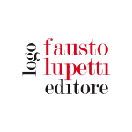 | 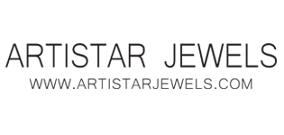 | 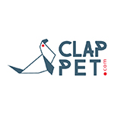
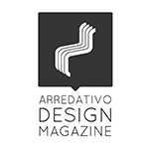 | 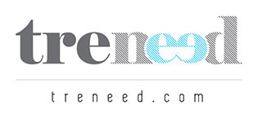 | 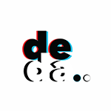
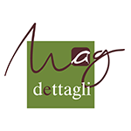 | 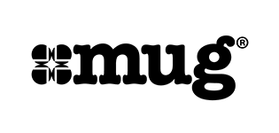
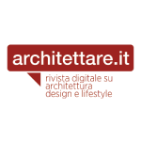 | 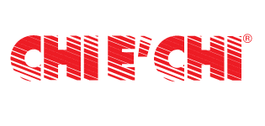
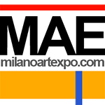 | 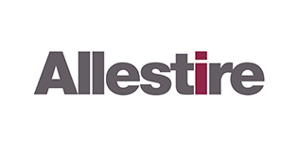 | 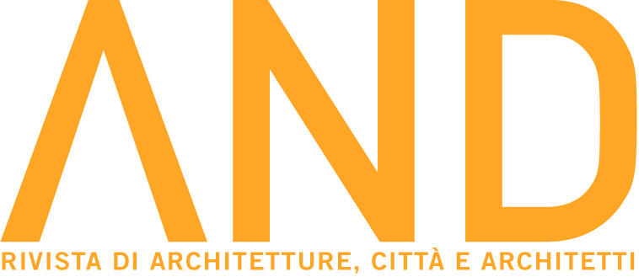
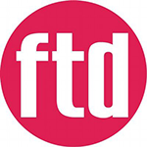
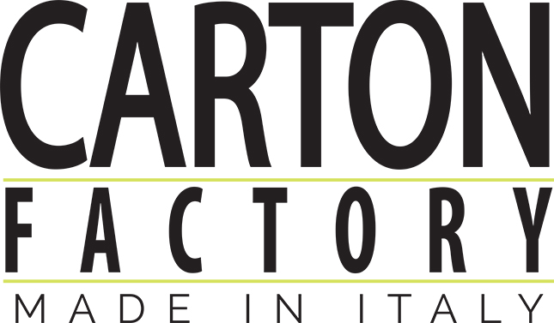 | 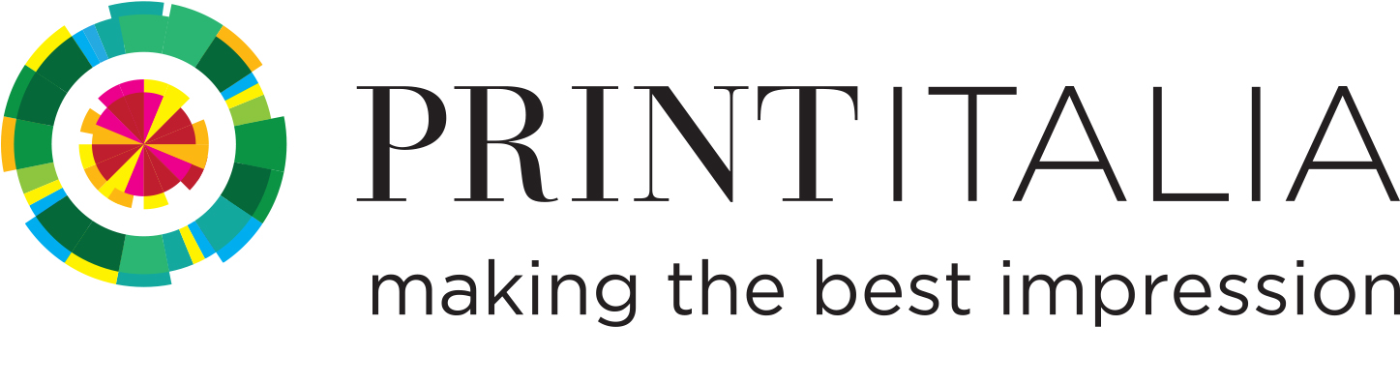
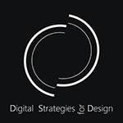 |  | 